Install Apache and run Apache on port number 82.
- Firstly create a instance, and then connect with bash using publicip of instace.
- Command : ssh -i webserver.pem ec2-user@publicipv4
- To install -> yum install httpd
- systemctl start httpd
- systemctl status httpd
- to change the port number from 80 to 81 by editing http.conf
- default configuration location /etc/httpd/conf/httpd.conf
- to change/create a static website by editing in /var/www/html
- default deployment location -> /var/www/html
- log file path -> /var/log/httpd/access_log
- And deployed a sample file by using index.html file
- 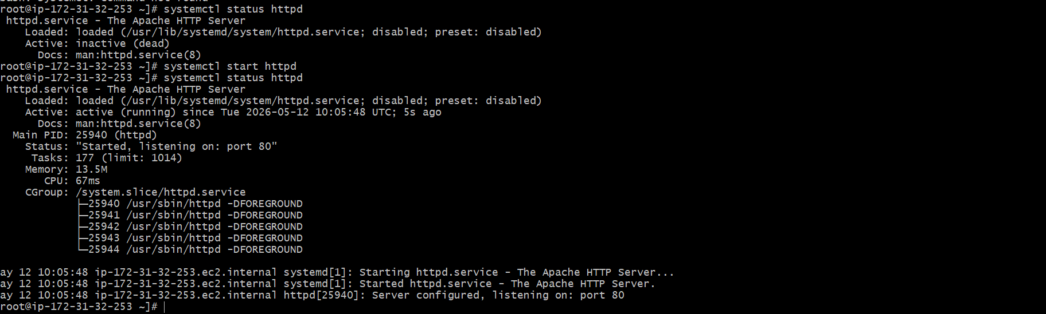
- 
- 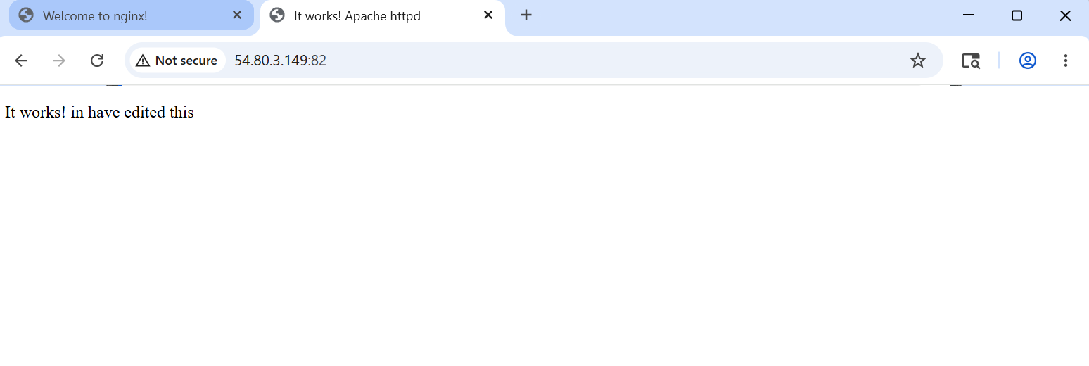

Install Nginx and run nginx on port number 81
- Yum install nginx -y
- Systemctl start nginx
- Systemctl status nginx
- Default deployment location -> /usr/share/nginx/html
- To change the port number from 80 to 81go to /usr/nginx/nginx.conf path and edit the nginx.conf file by using vi
- Log files -> /var/log/nginx
- 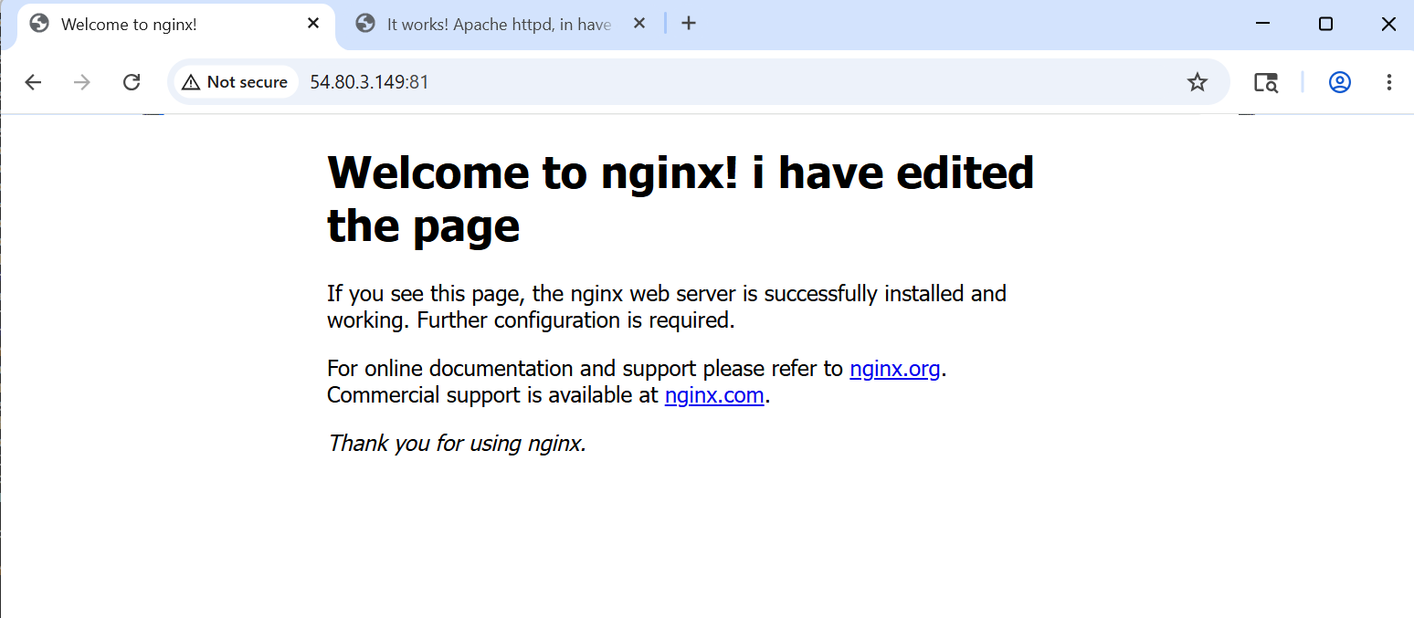

Install apache tomcat on port number 8080
- Firstofall download the java version 17 -> yum install java-17
- And then download tomcat by using wget command -> wget <url-of-the-link>
- By using wget command a tar fill will download and extract the downloaded file by using tar command -> tar xvf downloadedfilename
- And then go to bin directory use the startup.sh to run the tomcat
- To change the port number from default port 8080 to 8082, we have to edit the server.xml file and the path of this file -> /opt/tomcat/conf
- After editing the server.xml file we have to shutdown the tomcat and again start the tomcat -> shutdown.sh & startup.sh in bin directory
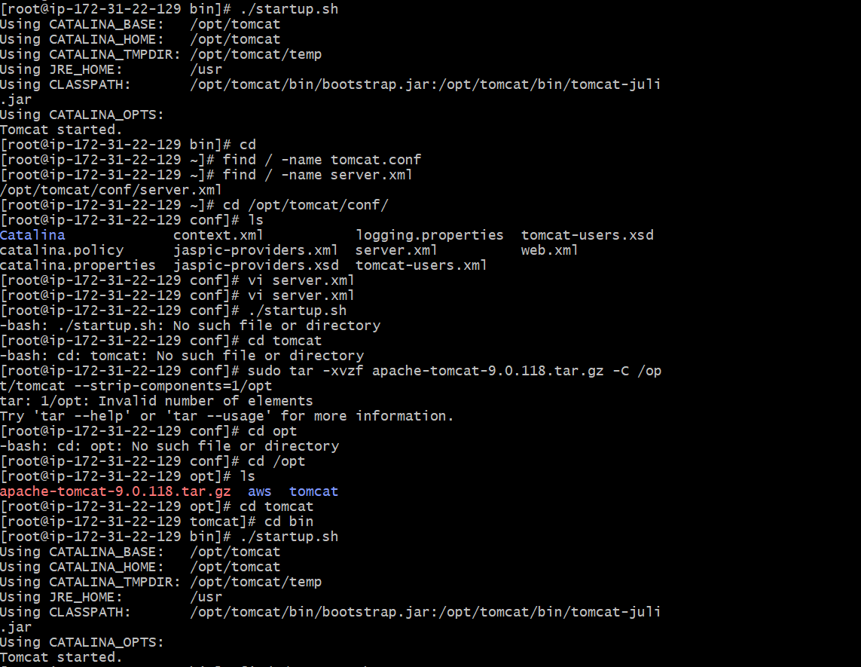

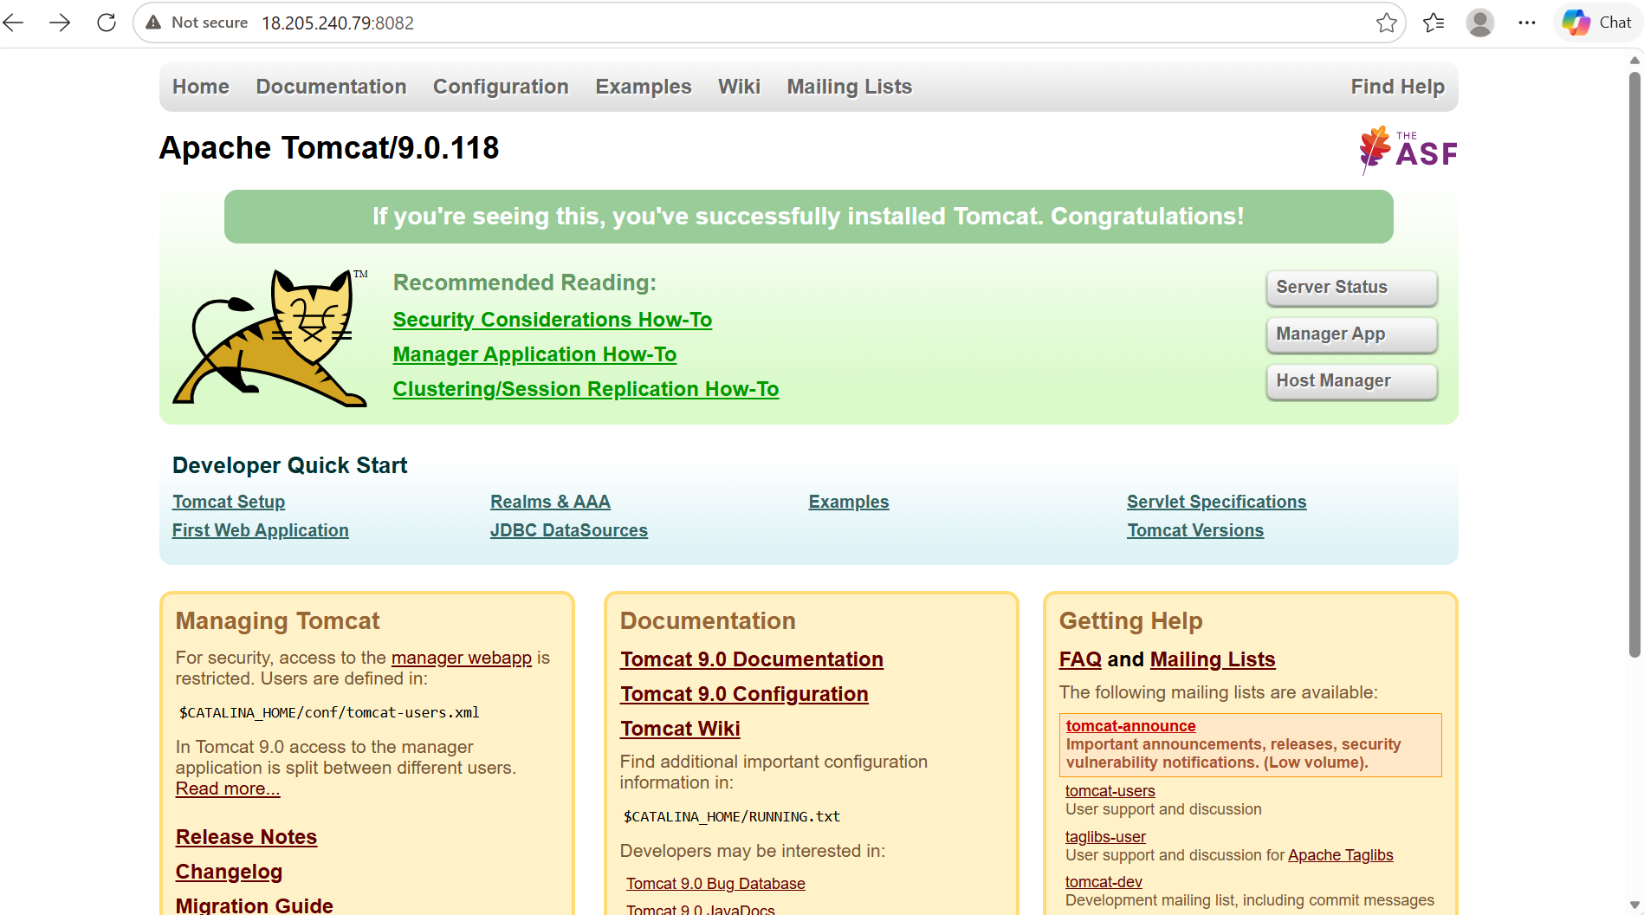

Deploy a sample app on webapps
- First go the webapps path -> /opt/tomcat/webapps
- This is the default deployment location of tomcat
- Download any sample app from google and download it in our service by using wget
- We can access this by publicip:8082/sample

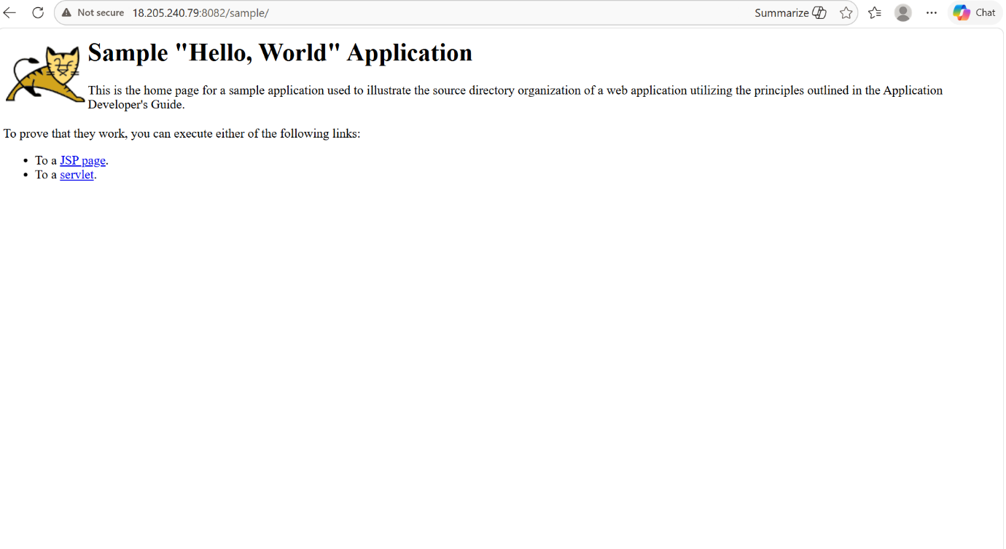

Create a tomcat.service file for apache
- We can create tomcat.service file in /etc/system/system
- Add a user tomcat by using adduser command and change the ownership of the downloaded tomcat file by using chown command -> chown tomcat:tomcat tomcat
- then give the java path of our service to the java home in tomcat.service file
- then do the commands
- systemctl daemon-reload
- systemctl enable tomcat
- systemctl start tomcat
- systemctl status tomcat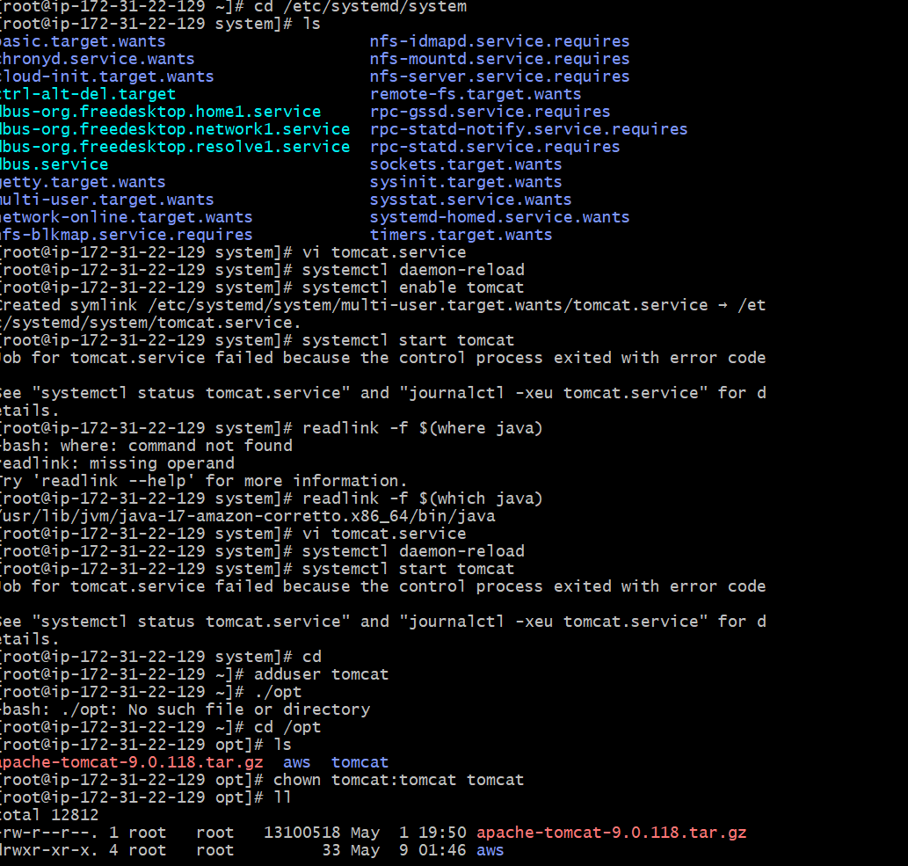
- 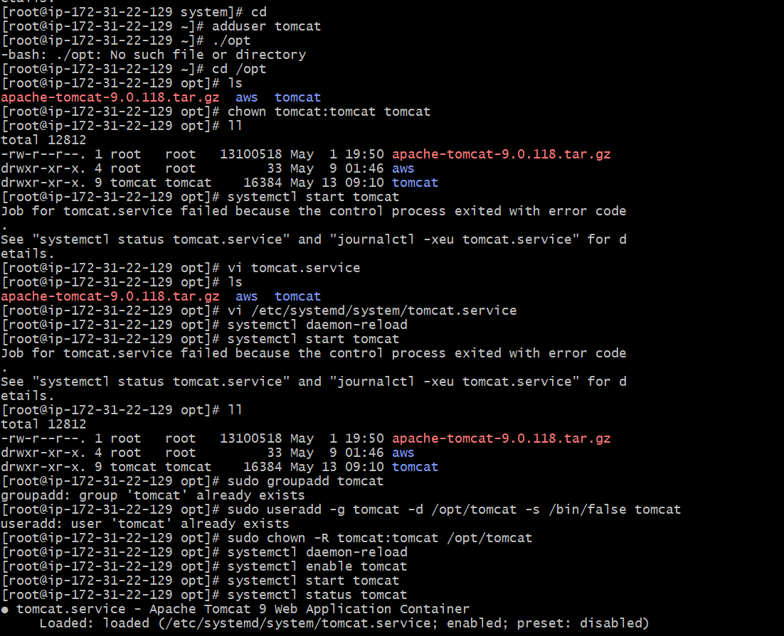

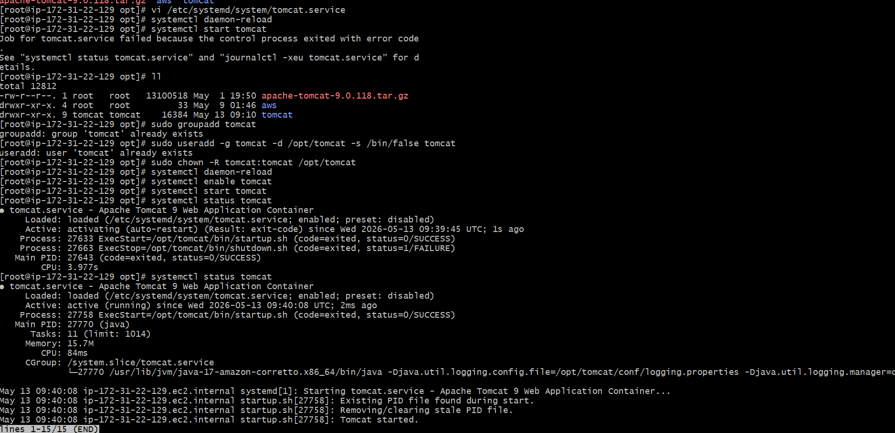

Configure HA PROXY server
- Launch 3 instances server1, server2 and haproxy server
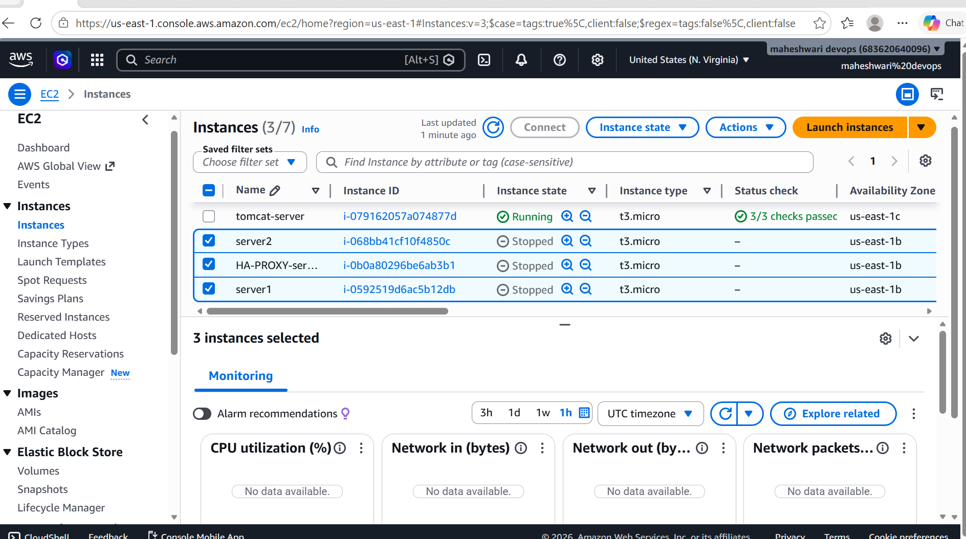
SERVER-1:
- Run the command to connect with platform
ssh -i webserver.pem ec2-user@publicip
- Then switch to the root user
- Then yum update -y
- Then install the apache -> yum install httpd -y
- To change the port number -> vi /etc/hosts
- Change the configurations -> publicip of haproxyserver load_balancer
- Run command -> ping load_balancer -c 4
- Systemctl start httpd
- Systemctl status httpd

SERVER-2:
- Run the command to connect with platform
ssh -i webserver.pem ec2-user@publicip
- Then switch to the root user
- Then yum update -y
- Then install the nginx-> yum install nginx-y
- To change the port number -> vi /etc/hosts
- Change the configurations -> publicip of haproxyserver load_balancer
- Run command -> ping load_balancer -c 4
- Systemctl start nginx
- Systemctl status nginx

HAPROXY SERVER:
- Run the command to connect with platform
ssh -i webserver.pem ec2-user@publicip
- Yum update -y
- Yum install haproxy -y
- Go to the /etc/hosts then add the server1 and server2 public ips
- Configure the /etc/haproxy/haproxy.cfg file
- Add public ips of two servers

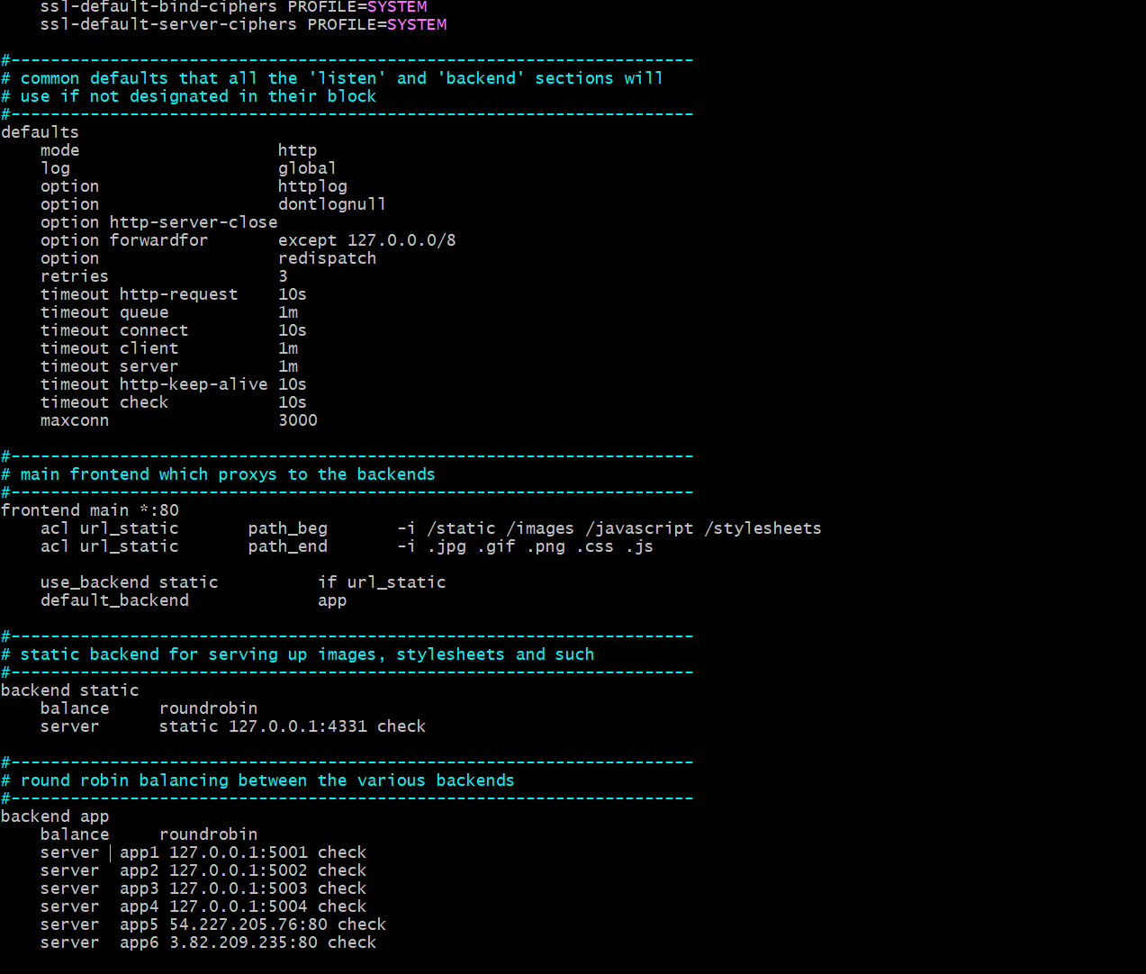
- Systemctl enable haproxy
- Systemctl start haproxy
- Systemctl status haproxy

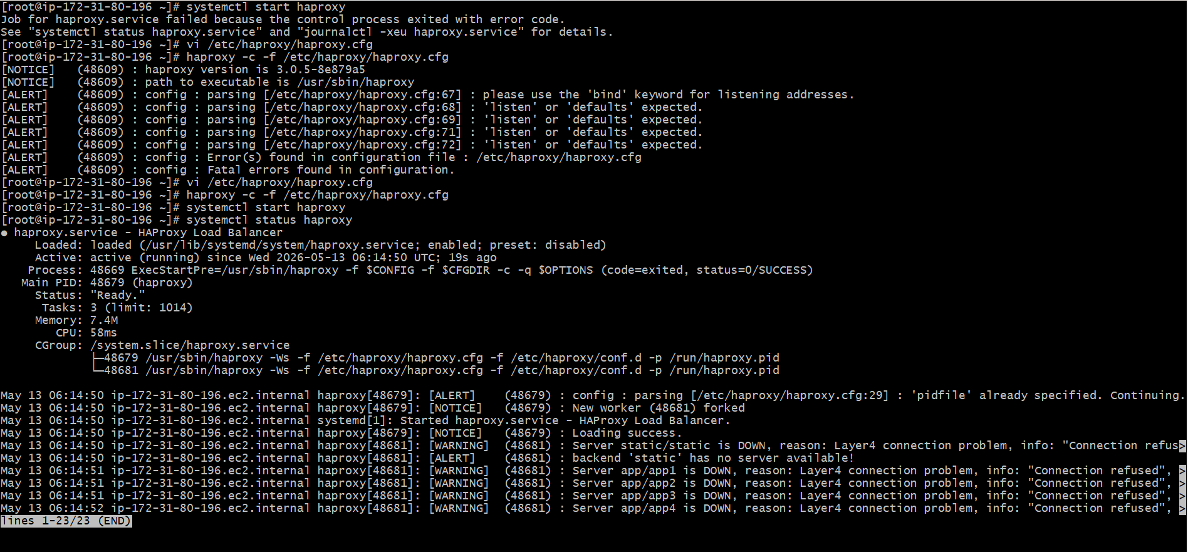
- Now haproxy server will act as load balancer to server1 and server2
